Market Research

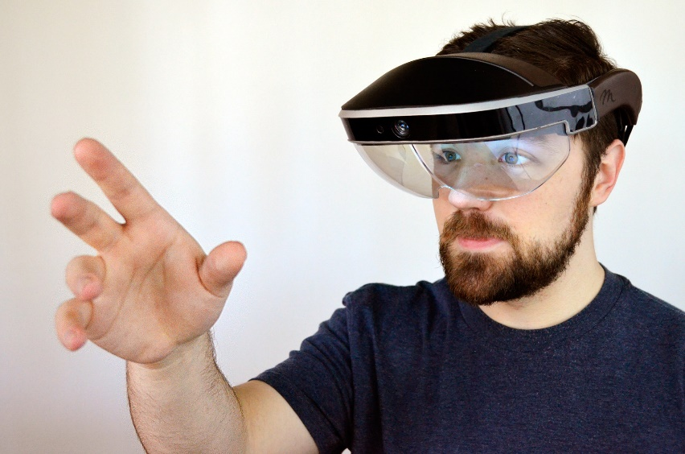Competitors

Meta 2

The Meta 2 is made by the Meta Company and is the successor to the Meta 1 AR development kit. The main differences that the Meta 2 has to the HoloLens are:

* 90 degree view an upgrade from the HoloLens' 35 Degree view, which has been a major problem reported with the HoloLens.
* Able to use more diverse gestures than the HoloLens such as using the whole hand to move blocks within the AR space.

Google Glass

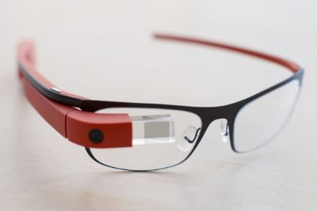

* Google search results appear in front of your face instantly
* Voice Translations
* Voice Dictation and Gesture Control
* Third Party Applications

Magic Leap

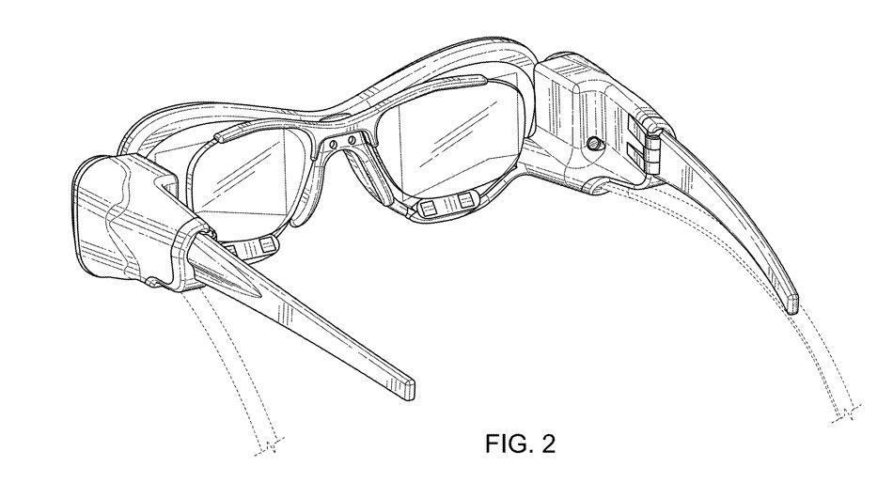

Magic Leap is one of the main competitors for the HoloLens as it promises an experience above and beyond the HoloLens', it says that it will be able to project images that react with the real world and images that look incredibly realistic by projecting the images directly onto the retina. So that they at perceived just like real life objects. Nothing has been heard from the Magic Leap for some time so I'm not sure whether it is stuck in development or just stopped in general.

References [1]<http://www.thewindowsclub.com/top-hololens-competitors>